
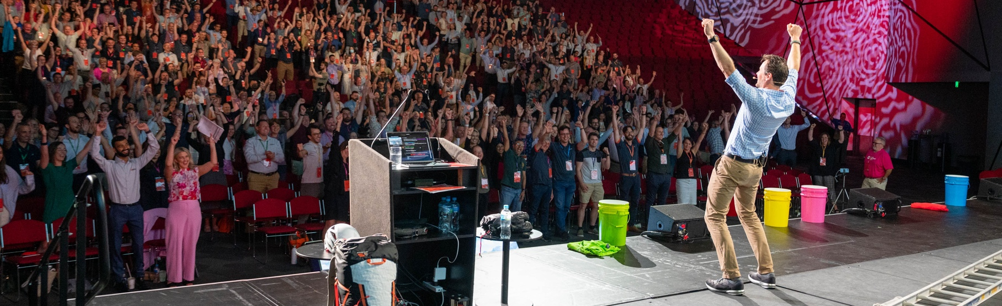

Daniel Bull Pre-Event Questionnaire
Please fill up as much as possible to assist Daniel in tailoring the presentation.
Event Details
Company name
Event Location
Event Date/s
Keynote Date
Virtual or In-Person
Keynote Length | Keynote: Q&A:
Number of Attendees

Details to tailor the Keynote
- What is the purpose of the event?
- Is there a theme/title?
- What are the current concerns/problems/challenges facing your organization?
- What are you hoping the audience will gain from Dan’s keynote?
- What sensitive topics should be avoided?
- Who will be in the audience?
- Are there any key people in the audience we should be aware of?
- Have you engaged other motivational speakers in the past? Who?
- Is there any other background information which may be relevant to make this a successful experience?
Logistics
- Timing
  - Arrival time:
  - Keynote start time:
  - Finish time:
- What will be happening before and after the presentation?
- Format of the room: ballroom, theatre, banquet… (Please share photos of the room if possible)
- Transport arrangement from to and from venue:
- Contact person on arrival at the venue:
- Contact for any emergency (include mobile number):
- When can Daniel do a tech check? Specify time and contact details.
Please email the completed questionnaire to team@unstoppabull.com.

